**SQL Basic Queries**

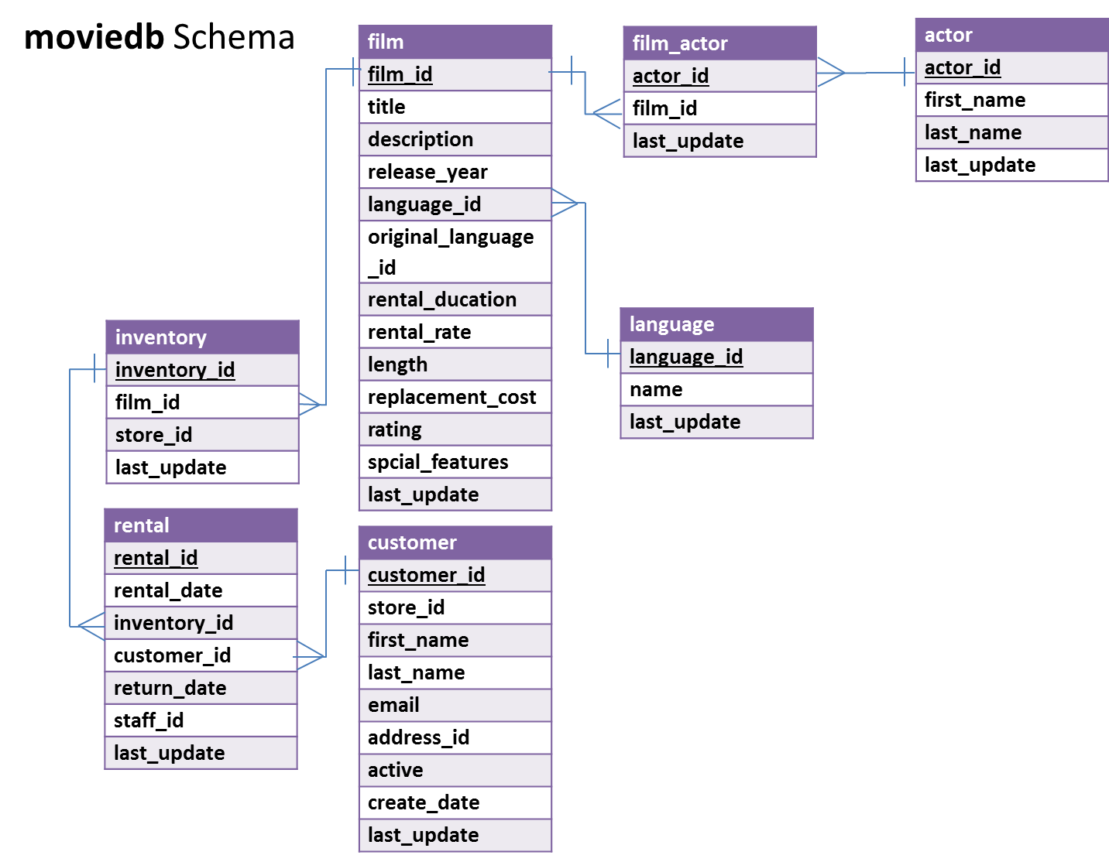

In MySQL Workbench, open the connection to the dataanalytics.temple.edu server using your username and password. Click on the “moviedb” schema and then the tables tab to see the list of tables.

**Questions**

1. What are the title and rental rate for films rated PG-13 and shorter than 50 minutes?

(Hint: R-rated movies have rating value equal to ‘R’)

*Display: movie title and rental rate*

1. What are the three most popular first names among the customers in the database? (Assume no ties)

*Display: first name and how many times that name appears in the database*

1. Display all languages of movies (without repetition) in the database.

(Hint: Languages are stored in ‘name’ column in language table)

*Display: name of the languages*

1. What is the average rental rate for each movie rating (i.e., G, PG, PG-13, R, NC-17)?

*Display: rating and average rental rate*

1. How many movies with a G rating mention ‘and’ in their description?  
   *Display: number of movies*
2. For different film ratings (i.e., G, PG, R, NC-17), which film rating has the highest average rental rate?

*Display: highest rating and its average rental rate*

1. How many customers are named “Paula Bryant”?

*Display: number of customers*

1. Return the first five unique last name of actors which starts with a letter “T” based on alphabetical order.

*Display: last name*

**ANSWER SHEET**

| **Question** | | **SQL Query** | **Results/Answer from MySQL Workbench** |
| --- | --- | --- | --- |
| 1 | What are the title and rental rate for films rated PG-13 and shorter than 50 minutes? | SELECT film.title, film.rental_rate  FROM moviedb.film  WHERE rating='pg-13' and length<50; | 'HALLOWEEN NUTS', '2.99'  'HAWK CHILL', '0.99'  'KWAI HOMEWARD', '0.99'  'LABYRINTH LEAGUE', '2.99'  'NOTTING SPEAKEASY', '0.99'  'PARADISE SABRINA', '2.99'  'RIDGEMONT SUBMARINE', '0.99'  'VALENTINE VANISHING', '0.99' |
| 2 | What are the three most popular first names among the customers in the database? | SELECT customer.first_name, COUNT(customer.first_name)  FROM moviedb.customer  GROUP BY customer.first_name  ORDER BY COUNT(customer.first_name)DESC LIMIT 3; | 'TERRY', '2'  'JESSIE', '2'  'JAMIE', '2' |
| 3 | Display all languages of movies (without repetition) in the database. | SELECT name  FROM language; | 'English'  'Italian'  'Japanese'  'Mandarin'  'French'  'German' |
| 4 | What is the average rental rate for each movie rating? | SELECT rating,  AVG(rental_rate)  FROM film  GOUP BY rating; | 'G', '2.888876'  'PG', '3.051856'  'PG-13', '3.034843'  'R', '2.938718'  'NC-17', '2.970952' |
| 5 | How many G movies mention ‘and’ in their description? | SELECT COUNT(*)  FROM moviedb.film  WHERE film.rating="G"  AND film.description  LIKE '%and%'; | '178' |
| 6 | For different film ratings (i.e., G, PG, R, NC-17), which rating has the highest average rental rate? | SELECT rating, avg(rental_rate)  FROM film  GROUP BY rating  ORDER BY avg(rental_rate) desc  LIMIT 1; | 'PG', '3.051856' |
| 7 | How many customers are named “Paula Bryant”? | SELECT COUNT(customer_id) AS 'number of customers'  FROM customer  WHERE first_name='Paula'  AND last_name='Bryant'; | '1' |
| 8 | Return the first five unique last name of actors which starts with a letter “T” based on alphabetical order. | SELECT distinct last_name  FROM actor  where last_name like 'T%'  order by last_name asc  LIMIT 5; | 'TANDY'  'TAUTOU'  'TEMPLE'  'TOMEI'  'TORN' |